**STEPS DONE FOR DELETION OF STALE BRANCHES IN GTP**

**Step 1:** Run the following queries to get already merged branches and branches that have not yet been merged.

<https://eyglobaltaxplatform.visualstudio.com/Global%20Tax%20Platform/_git/devops?path=%2Fmaintenance%2Fbranches%2Fscripts%2FGet-StaleMergedBranches.bat&version=GBmaster>

<https://eyglobaltaxplatform.visualstudio.com/Global%20Tax%20Platform/_git/devops?path=%2Fmaintenance%2Fbranches%2Fscripts%2FGet-StaleNotMergedBranches.bat&version=GBmaster>

**Run Bat script.**

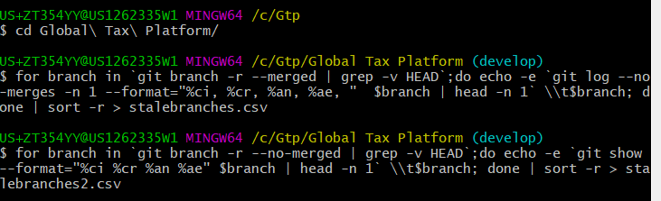

**Step 2:** Upload csv and scripts to Maintenance folder in DevOps repo

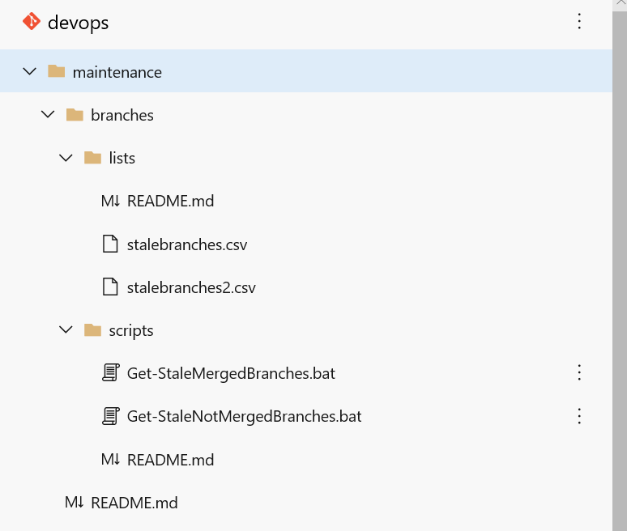

**Step 3:** Filter the two sheets on the blue column for delete and union to one sheet. Give a header name to the branch.

**Step 4:** Run the script that loops each row and delete the branch

Link to script - <https://eyglobaltaxplatform.visualstudio.com/Global%20Tax%20Platform/_git/devops?path=%2Fmaintenance%2Fbranches%2Fscripts%2FDelete-StaleBranches.ps1&version=GBmaster>